Unique key, primary key , not null and foreign key are physical key/ physical constrains (i.e) that can be applied on db tables at various levels.

Candidate key, natural key, surrogate key are logical key/logical constrains (i.e) There is theory concept but no practical concept for them.

**1.Candidate Key:-**  The column that allows unique values and also can be used for accessing records of table is called candidate key.

Ex:-

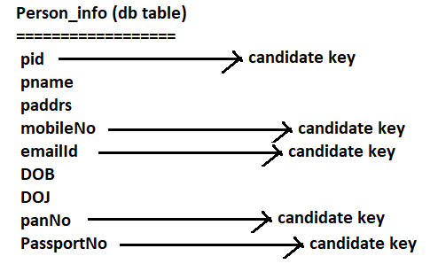

One table can have multiple candidate keys. One of the Candidate keys is selected as “Primary key”.

**1.2. Natural Key:-** The column that allows unique values and can expect values from end user and value will be changed based on business policies of govt,out side world is called Natural key.

EX:- Aadhar no, mobile no, panno, passportno and etc.

As of now, Aadhar no have only 12 digits. When Indian population increases, Indian govt may change aadhar no policy. New policy is Aadhar no should have 16 digits.

**Limitation of Natural key:-**

a. Column values are lengthy. So more memory is required to store them.

b. These column values are supplied by end user. If end-user don’t give these value, Record insertion may fail.

For above two reasons, Natural key is not taken as primary key.

**1.3.Surrogate key:-** The candidate key whose value is generated from underlying DB s/w and underlying app is called surrogate key.

Ex:- student_id, Emp_id, order_id, Transaction_id …etc.

**Advantages of Surrogate key:-**

1. Column values are small. So small amount of memory is required to store them.
2. These column values are not supplied by end user.

Generally surrogate key column is taken as primary key for above two reasons.